CS 255 System Design Document Template
Project Two – DriverPass System Design
Kamaljit Rooprai

UML Diagrams

UML Use Case Diagram
This diagram below shows the different people and outside systems who use DriverPass, and what they can do. A customer can sign up, book a lesson, or cancel/change a booking on their own. The secretary can do those same booking tasks over the phone as well as in person for a customer who calls in. Ian, the IT officer, handles account resets and access. Liam, the owner, can turn training packages on or off and pull activity reports. Drivers log their notes and lesson times, and the DMV system feeds in updated rules and practice tests automatically.

Image 1. UML Use Case Diagram: DriverPass System
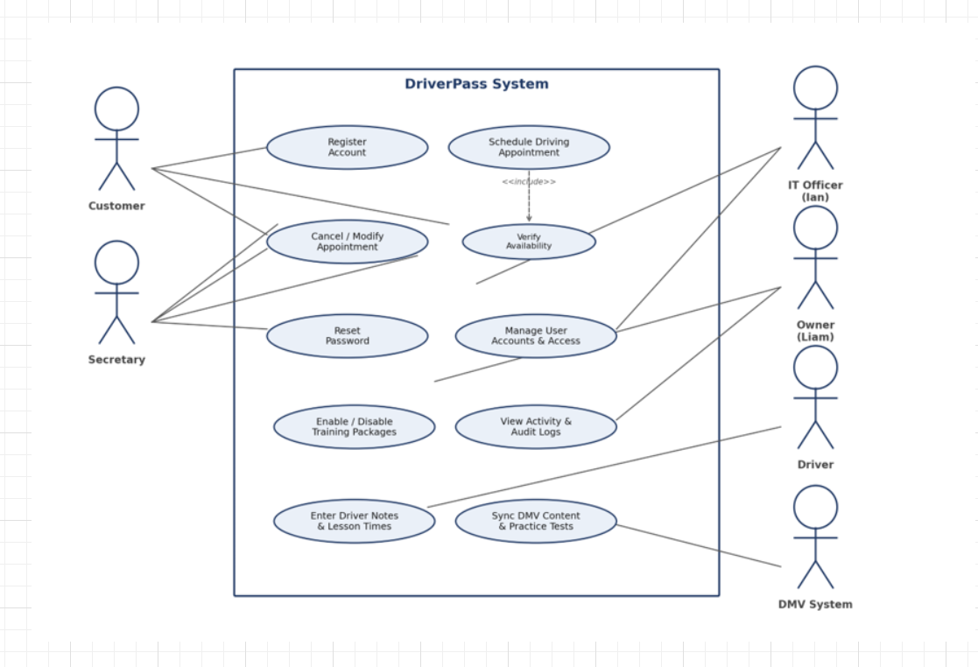

UML Activity Diagrams
Actually, I picked up two use cases to break down step by step scheduling a driving appointment since that is the heart of the business and resetting a password, it’s something every user type will need at some point.
Scheduling a Driving Appointment: customer picks a day and time, the system checks whether a car and driver are really free for that slot. If so, then walks them through payment before locking in the reservation and sending a confirmation. If the slot is not open or card is declined, then the customer gets a precise message and a chance to try again instead of the booking quietly failing.
Activity Diagram Below: Schedule Driving Appointment
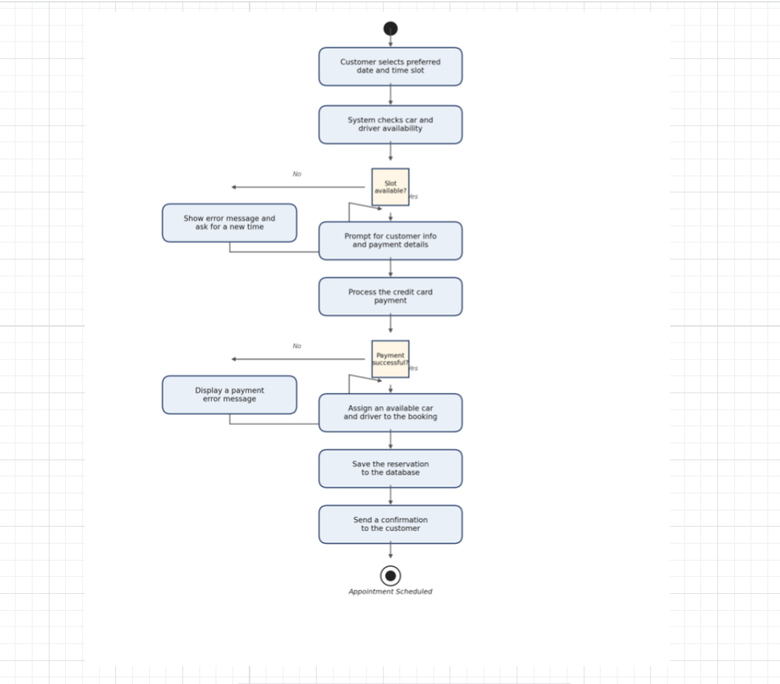

Image 2. Activity Diagram Above: Schedule Driving Appointment

Resetting Password: this covers what happens when someone forgets their login credentials. Then, they ask for a reset, the system checks that the email is tied to an account for real. If it is, then it sends a secure link they can use to set a new password. If the email is not recognized, they just get a friendly error instead of any hint about which emails exist in the system which matters for security purposes.

Activity Diagram Below: Reset Password
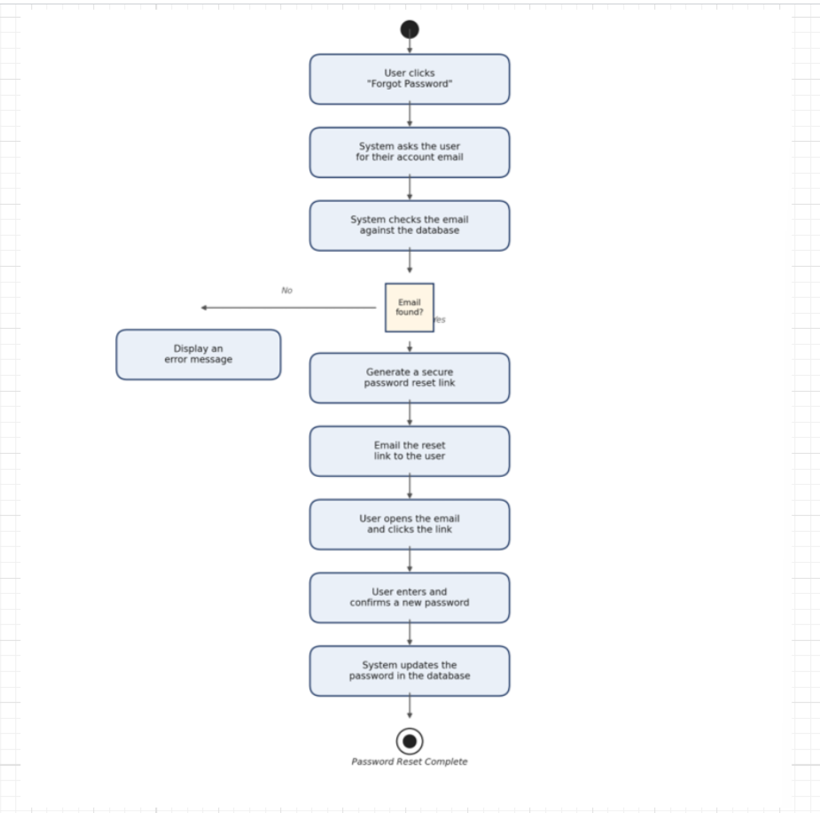

Image 3: Activity Diagram Above: Reset Password

UML Sequence Diagram
This diagram follows the “Schedule a Driving Appointment” use case again., but this time it shows the back and forth between the real pieces of the system: the customer, the website, the booking logic, and the database, It is really a play by play of the messages that get passed around behind the scenes by checking availability, saving the booking, and sending back a confirmation. So, the developers know exactly what needs to talk to what.

Sequence Diagram Below: Schedule Driving Appointment
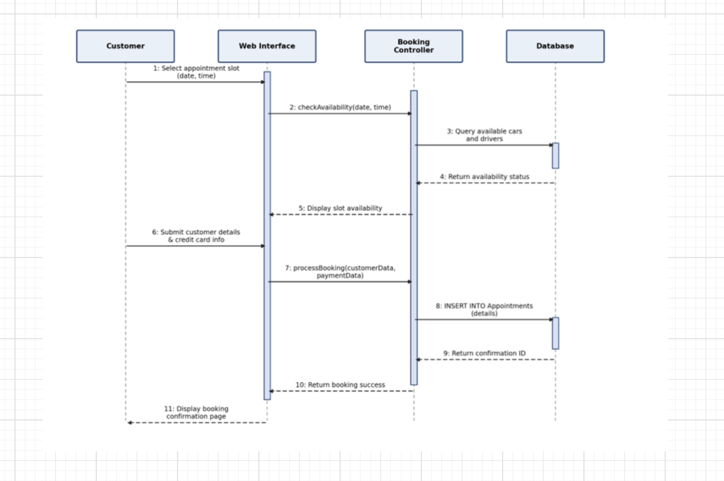

Image 4. UML Sequence Diagram Above: Schedule Driving Appointment

UML Class Diagram
This diagram lays out the main “things” the system needs to keep track of and how they really connect. A Customer schedules Appointments. Each Appointment gets matched with one Driver and one Car. Customers sign up for a Package the six/eight/twelve hour options Lian described, and every meaningful action gets written to an AuditLog so there is always a record of who did what by which covers the tracking and accountability piece Liam asked for.

Class Diagram Below: DriverPass System

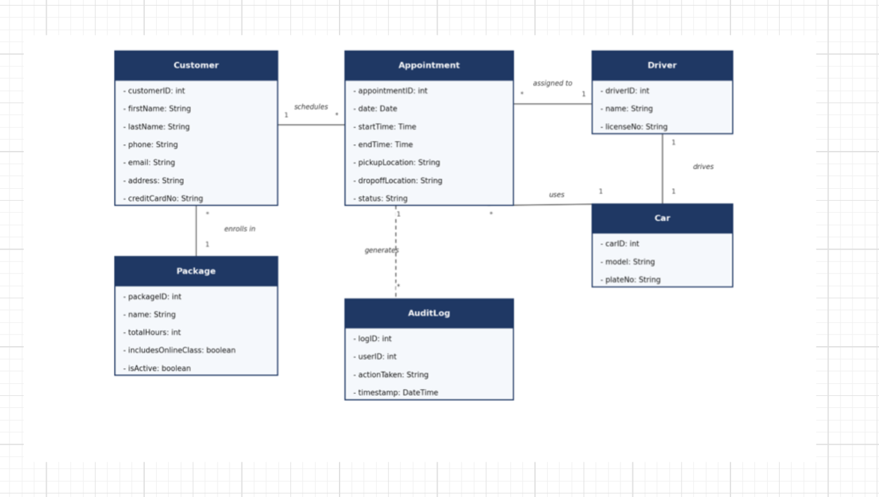
Image 5 UML Class Diagram Above: DriverPass System

Technical Requirements

The system will really need to run, in simple terms, based on everything DriverPass told us they needed:

Hardware
- A server to run the website and the database: nothing fancy, just a strong dual-core machine with 16 GB of RAM and superfast SSD drive so pages load rapidly, even when a lot of customers are booking at once.
- Customers and staff need a steady computer, tablet, or phone with a web browser: no special equipment or app install required.
- Drivers get a simple mobile friendly page to check their schedule and jot down lesson notes, so they don’t need a laptop in the car.

Software
- The server runs on standard, reliable software Linux or Windows Server with a normal web ser like Apache or Nginx handling traffic.
- All of the customer, appointment, and driver information lives in a regular relational database like MySQL or PostgreSQL: nothing exotic, just something proven and easy to maintain.
- Website itself is built with daily web tools HTML, CSS, JavaScript on the front end, and a standard backend framework such as Node.js or Django to handle the logic behind bookings, accounts, and payments.

Outside Connections and Tools
- The diagrams I my document were built in Lucidchart, where the dev team should keep using going forward so everything stays steady.
- A secure, PCI compliant payment processor like Stripe or PayPal handles the credit card charges, so DriverPass never has to store raw card umbers themselves; that is a big liability off their plate.
- A live connection to the DMV feeds in updated rules, policies, and practice questions automatically, the training content never goes stale.

Security and Infrastructure
- The entire system is hosted in the cloud like Azure or AWS, which is exactly what Liam asked for: he can check things from anywhere, on any device, without worrying about servers going down or losing data.
- Everything is backed up automatically off-site, so nobody at DriverPass has to think about backups; it just happens.
- Every page uses HTTPS SSL/TLS, so credit card numbers and personal details are encrypted whenever they travel over the internet.
- Each type of user customer, secretary, driver, IT officer, owner only sees and can do what makes sense for their role, this is what let Ian, as the IT officer, reset accounts and shut off access for someone who is left the company without giving that same power to everyone.
- Every cancellation, booking, and change gets logged automatically with who did it and when, so if something ever needs to be looked into, there’s always a precise paper trail by covering the accountability piece Liam brought up in our interview.

